


Final Project（Fundamentals of Optoelectronics）

Thesis Title：《2025-Project Fundamentals of Optoelectronics》
Name（Student ID）
Grape（Major） Grade 22 (Electronic Science and Technology)
Faculty College of Information and Electronic Engineering
Submitted Date 2025.06.15

2025-Project Fundamentals of Optoelectronics

Question 1: Distributed Bragg Reflector (DBR)
In a waveguide of Distributed Bragg Reflector (DBR), it consists of layers of high refractive index and low refractive index. The average effective refractive index is 2.5.The operating wavelength of the DBR structure is 1550 nm.
- Determine the period of the Distributed Bragg Reflector structure.
- State the application of DBR structure in the optoelectronics.

Solution 1
a. Period of the DBR Structure
The period$(Λ)$ of a DBR structure is determined using the “Bragg condition”, which relates the average effective refractive index $((n_{avg}))$, the operating wavelength $((λ))$, and the period:
$$λ=2⋅n_{avg}⋅Λ$$
Rearranging for $(Λ)$:
$$Λ=\frac{λ}{2⋅n_{avg}}$$
Given:
$$n_{avg}=2.5$$
$$λ=1550nm$$
Calculation:

$$Λ=\frac{1550}{2×2.5}=\frac{1550}{5}=310nm$$
Result:
The period of the DBR structure is 310 nm.

b. Application of DBR Structures in Optoelectronics
DBR structures are primarily used as ‘high-reflectivity mirrors’ in optoelectronic devices due to their ability to selectively reflect specific wavelengths.
Key applications include:
1. Semiconductor Lasers:
DBRs form mirrors in Vertical-Cavity Surface-Emitting Lasers (VCSELs) and Distributed Feedback (DFB) lasers, enabling wavelength-stable operation at telecommunications wavelengths (e.g., 1550 nm).
2. Optical Filters:
They act as narrowband reflectors in wavelength-division multiplexing (WDM) systems, filtering specific channels.
3. Photonic Integrated Circuits (PICs):
DBRs provide on-chip reflectivity for resonators, modulators, and sensors.
Conclusion:
DBRs are critical for wavelength selectivity and light confinement in modern optoelectronic systems.

Question2: Semiconductor Lasers
The parameters of a InGaAsP/InP semiconductor laser are listed in the attachment. The corresponding calculation and simulation of semiconductor lasers need to be completed based on the attached parameters.
- Calculate the mirror loss $α_{m}$ and determine the threshold gain$g_{th}$.
b. Based on rate equations, simulate the I-V and I-P curves of the semiconductor laser;obtain the threshold current and the output power when I=1.2Ith in the steady state.

Solution 2:
- Mirror Loss${ α}_{m }$and Threshold Gain$g_{th}$.
Mirror Loss $(α_{m})$:
The mirror loss is calculated using the formula for a laser cavity with two facets:
$$α_{m}=\frac{1}{2L}\ln\left(\frac{1}{R_{1}R_{2}}\right)$$
Given:
Cavity length$(L=800μm=0.08cm)$
Facet reflectivities $(R_{1}=R_{2}=0.35)$
Calculation:
$$R_{1}R_{2}=0.35×0.35=0.1225$$
$$\frac{1}{R_{1}R_{2}}=\frac{1}{0.1225}≈8.1633$$
$$\ln{(}8.1633)≈2.100$$
$$α_{m}=\frac{1}{2×0.08}×2.100=\frac{2.100}{0.16}=13.125{cm}^{−1}$$
Result:
$$α_{m}=13.125{cm}^{−1}$$
Threshold Gain$(g_{th})$:
The threshold gain is given by:
$$g_{th}=\frac{α_{i}+α_{m}}{Γ}$$
Given:
Internal loss$(α_{i}=13{cm}^{−1})$
Mirror loss$(α_{m}=13.125{cm}^{−1})$
Optical confinement factor $(Γ=0.07)$

Calculation:
$$g_{th}=\frac{13+13.125}{0.07}=\frac{26.125}{0.07}≈373.214{cm}^{−1}$$
Result：
$$g_{th}=373.214 {cm}^{−1}$$

b. Simulation of I-V and I-P Curves, Threshold Current, and Output Power
In order to ensure the correct answer, we use formula derivation and MATLAB simulation to solve this problem .

- Formula Derivation
Calculate Threshold Carrier Concentration $(n_{th})$：
The threshold carrier density $(n_{th})$ is derived from the gain equation:
$$g=\frac{g_{0}'}{v_{g}}(n−n_{0})$$
Given：
$$g_{0}'=7×10^{−6}{cm}^{3}⋅s^{−1}$$
$$v_{g}=8.82×10^{9}cm/s$$
$$g_{0}=\frac{g_{0}'}{v_{g}}=\frac{7×10^{−6}}{8.82×10^{9}}=7.937×10^{−16}{cm}^{2}$$
Threshold Carrier Density$(n_{th})$:
$$g_{th}=g_{0}(n_{th}−n_{0})$$
$$n_{th}=n_{0}+\frac{g_{th}}{g_{0}}=1.75×10^{18}+\frac{373.43}{7.937×10^{−16}}=2.2205×10^{18}{cm}^{−3}$$

The active region volume$(V)$ is:
$$V=d×h×L=(10μm)×(50nm)×(800μm)$$
$$d=10×10^{−4}cm=0.001cm$$
$$h=50×10^{−7}cm=5×10^{−6}cm$$
$$L=800×10^{−4}cm=0.08cm$$
$$V=0.001×5×10^{−6}×0.08=4×10^{−10}{cm}^{3}$$

Threshold current $(I_{th})$ :
Below threshold, carrier density builds to $n_{th}$ with negligible stimulated emission. The recombination rate is dominated by spontaneous emission, with carrier lifetime：
$$τ_{r}=1ns=10^{−9}s$$
$$I_{th}=\frac{q⋅V⋅n_{th}}{τ_{r}}$$
$$q=1.602×10^{−19}C$$
$$I_{th}=\frac{(1.602×10^{−19})×(4×10^{−10})×(2.2205×10^{18})}{10^{−9}}$$
$$=0.1423A$$
$$=142.3mA$$
Result:
Threshold current $I_{th}=142.3mA.$

·The I-V curve :
The ideal diode equation（the Shockley Diode Equation） is
$$V=\frac{nkT}{q}· ln(\frac{I}{I_{0}}+1)$$
This equation accurately captures the exponential relationship between current and voltage in the forward-bias region, especially when the diode starts to conduct. This is the true non-linear behavior of a p-n junction.
For a semiconductor laser, the I-V curve is still fundamentally described by a diode equation like this, but with some additional considerations:Series Resistance (Rs). In real laser diodes, there's always a series resistance from the contacts and bulk material. This resistance adds a voltage drop linearly with current. So, a more complete model would be:
$$V=\frac{nkT}{q}·ln(\frac{I}{I_{0}}+1)+I⋅R_{s}$$
However$,(n) ,(I_{0}), (R_{s})$were not provided in problem statement. If they were, I would definitely use this more sophisticated model. Since they weren't provided, I used the simplified linear model for the I-V part, as it's common when such detailed electrical parameters are unavailable. The I-V curve is modeled as :
$$V=V_{d}+I⋅R_{s}$$
where $(V_{d})$is the diode turn-on voltage (approximated as the bandgap voltage for $(λ_{0}=1550nm))$ and$(R_{s})$ is the series resistance (assumed $5Ω$) based on typical values, as not provided.
Bandgap energy：
$$E_{g}≈\frac{hc}{λ_{0}}=\frac{1240}{1550}≈0.8eV$$
So：
$$V_{d}≈0.8V$$
·The I-P curve :
$$P_{out}=η_{d}⋅\frac{ℏω}{q}⋅(I−I_{th})$$
Below threshold $((I<I_{th}))$: Output power is low (spontaneous emission).
Above threshold $((I≥I_{th}))$: Output power increases linearly with current.
Internal quantum efficiency$(η_{i}=1)$(assumed, as not provided).
Output power is from one facet (symmetric cavity).
Output Power at$(I=1.2I_{th})$:
Above threshold, carrier density clamps at$(n_{th})$, and additional current converts to stimulated emission.
The standard formula for output power is:
$$P_{out}=η_{d}⋅\frac{ℏω}{q}⋅(I−I_{th})$$
Given：
$$ℏω=\frac{hc}{λ_{0}}$$
$$η_{d}=η_{i}⋅Γ⋅\frac{α_{m}}{α_{i}+α_{m}}$$
$$h=6.626×10^{−34}J·s$$
$$c=3×10^{8}m/s$$
$$λ_{0}=1550×10^{−9}m$$
$$Γ=0.07$$
$η_{i}=1$（Based on assumptions of the usual situation）
Calculation：
$$ℏω=\frac{(6.626×10^{−34})×(3×10^{8})}{1550×10^{−9}}≈1.282×10^{−19}J$$
$$、\frac{ℏω}{q}=\frac{1.282×10^{−19}}{1.602×10^{−19}}≈0.800V$$
$$\frac{α_{m}}{α_{i}+α_{m}}=\frac{13.14}{13+13.14}=0.5027$$
$$η_{d}=1×0.07×0.5027=0.0352$$
Result：
$$P_{total}=η_{d}\frac{hν}{e}(I−I_{th})=0.0352×0.8006×0.02842≈0.800mW$$
If single-sided output is explicitly requested for identical facets, then divide this total power by 2：
$$P_{single}=\frac{1}{2}P_{total}=\frac{1}{2}η_{d}\frac{hν}{e}(I−I_{th})$$
$$P_{single}=\frac{1}{2}×0.800=0.400mW$$
Result:
Output power at$I=1.2I_{th}$ is $0.400mW$(from one facet).

- Simulation Results:
·I-V Curve:
Below threshold: Diode-like behavior $(V≈V_{d}+I⋅R_{s})$ with $(V_{d}≈0.8V)$and$(R_{s}=5Ω)$.
Above threshold: Voltage increases linearly with current due to series resistance.
Simulated I-V curve:
At $(I=0A)$, $(V=0V)$
At $(I=I_{th}=0.1423A)$, $(V≈0.8+0.1423×5=1.5115V)$
At $(I=0.1708A),(V≈0.8+0.1708×5=1.654V)$

·I-P Curve:
Below threshold: Power negligible (spontaneous emission).
Above threshold: Linear increase $(P_{out}=η_{d,one}⋅\frac{ℏω}{q}⋅(I−I_{th}))$with slope $(≈0.201W/A).$
Simulated I-P curve:
Threshold at $(I_{th}=142.3mA)$
At$(I=0.1708A),(P_{out}=0.800mW)$(total)
At$(I=0.1708A),(P_{out}=0.400mW)$(from one facet)

MATLAB:
From both facets:
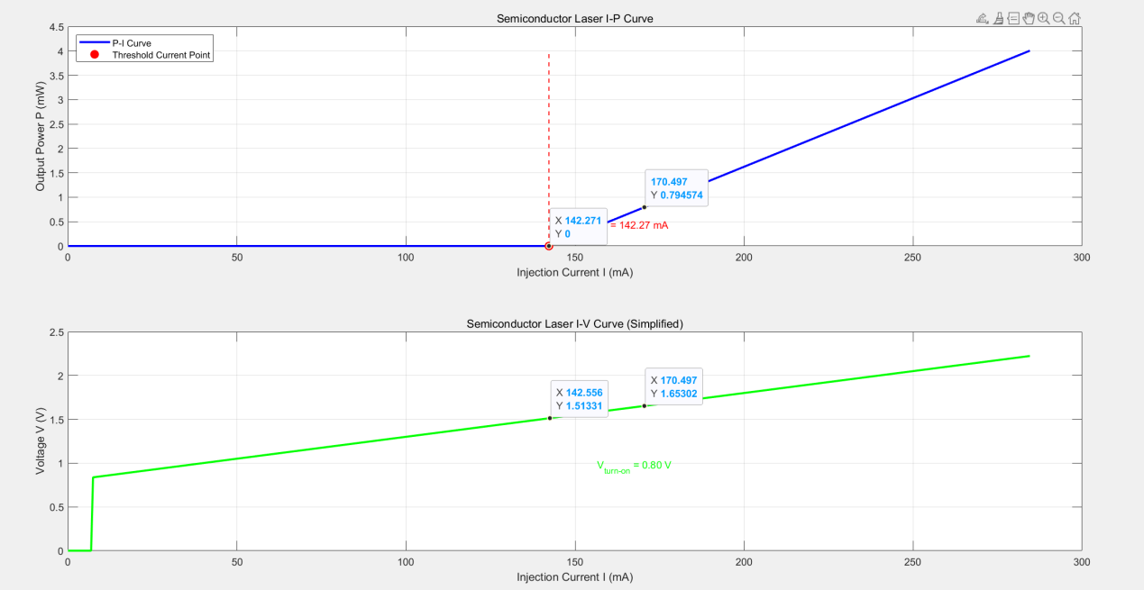
From one facet:
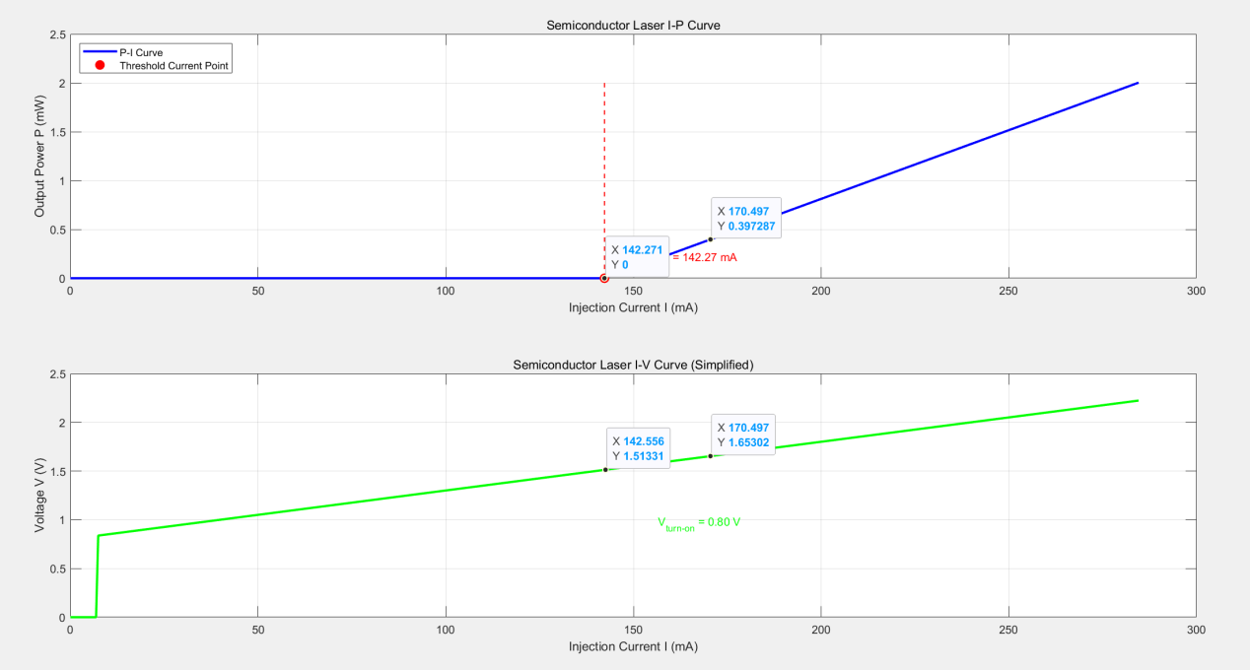

Question3: Single-mode lasers
a. List at least three methods to achieve single-mode operation in semiconductor lasers.
b. Investigate the current development status of single-mode lasers, including advantages, application fields and development bottlenecks etc..

Solution 3：
a. Methods to Achieve Single-Mode Operation in Semiconductor Lasers
Achieving single-mode operation in semiconductor lasers means ensuring that only one specific longitudinal mode (and usually also a single transverse mode) oscillates, providing a narrow linewidth and long coherence length. This is crucial for many applications requiring precise wavelength control and high spectral purity.
Here are at least three common methods:
1. Distributed Feedback (DFB) Lasers:
·Principle: Instead of discrete mirrors at the ends of the cavity, DFB lasers incorporate a periodic grating structure directly within or adjacent to the active region. This grating acts as a distributed Bragg reflector, providing wavelength-selective feedback along the entire length of the cavity. Only wavelengths that satisfy the Bragg condition for the grating experience strong feedback and thus can lase. By designing the grating period precisely, a single longitudinal mode can be selected. Often, a quarter-wavelength phase shift is introduced in the grating at the center of the cavity to ensure a strong single mode and avoid degenerate modes.
·How it achieves single-mode: The strong wavelength selectivity of the distributed grating suppresses other longitudinal modes, allowing only one mode to reach threshold and dominate.

2. Distributed Bragg Reflector (DBR) Lasers:
·Principle:Similar to DFB lasers, DBR lasers also use gratings for wavelength selection. However, in DBR lasers, the gratings are typically located in passive waveguide sections outside the active gain region, acting as highly reflective, wavelength-selective mirrors. The active region itself is usually a Fabry-Pérot cavity. By designing the grating period, specific wavelengths are reflected back into the active region, while others are transmitted out.
·How it achieves single-mode: The DBR mirrors provide wavelength-selective feedback, similar to DFB lasers, but with the advantage of being able to tune the wavelength by varying the current injected into the DBR sections, which changes their refractive index. This makes them widely used for tunable single-mode operation.

3. Short Cavity Length (Fabry-Pérot Lasers with Short Cavities):
·Principle: In a standard Fabry-Pérot (FP) laser (which uses cleaved facets as mirrors), multiple longitudinal modes can oscillate if the gain bandwidth is wider than the mode spacing. The spacing between longitudinal modes $(Δλ)$ is inversely proportional to the cavity length $(L):Δλ$ = $\frac{λ_{0}^{2}}{2n_{eff}L},$where $λ_{0}$is the central wavelength and $n_{eff}$is the effective refractive index.
·How it achieves single-mode:By making the cavity length $L$very short, the longitudinal mode spacing$(Δλ)$ can be increased significantly. If this mode spacing becomes larger than the gain bandwidth of the active material, then only one longitudinal mode will fall within the gain curve and be able to lase, effectively achieving single-mode operation.
·Limitations:While conceptually simple, achieving very short cavities can lead to higher mirror losses and higher threshold currents. Maintaining stable single-mode operation over a wide operating range can also be challenging due to mode hopping.

Other methods include:
External Cavity Lasers (ECLs): Coupling the semiconductor laser to an external cavity with a wavelength-selective element (like a grating or etalon) to provide narrow-band feedback.
Injection Locking:Injecting light from a stable, low-power, single-mode "master" laser into a higher-power "slave" laser to force the slave laser to oscillate at the master's wavelength.
Coupled-Cavity Lasers:Using multiple coupled cavities to create a complex spectral filter that favors a single mode.

- Current Development Status of Single-Mode LasersSure

Current Development Status of Single-Mode Lasers
Single-mode lasers, particularly semiconductor lasers, are highly mature technologies that continue to evolve. They are characterized by their ability to emit light at a very specific wavelength with a narrow linewidth, meaning the light waves are highly coherent and maintain their phase over long distances.
- Advantages of Single-Mode Lasers:
  - Narrow Linewidth and High Coherence:
This is the most significant advantage. It allows for:
·High-resolution spectroscopy: Distinguishing between very closely spaced absorption or emission lines.
·Long-range interferometry: Measuring distances or detecting subtle changes with high precision.
·Coherent optical communication: Enabling higher data rates and greater transmission distances by allowing for more sophisticated modulation schemes that utilize the phase of light.
1.2 High Spectral Purity: Essential for applications where precise wavelength control is critical, such as:
·Wavelength Division Multiplexing (WDM): Packing multiple data channels onto a single fiber by using different, precisely spaced wavelengths.
·Atomic clocks and quantum technologies: Requiring extremely stable and specific wavelengths to interact with atomic transitions.
1.3 Tunability: Many single-mode laser designs (e.g., Distributed Bragg Reflector (DBR) lasers, Sampled Grating DBR (SG-DBR) lasers) offer precise and often rapid wavelength tunability, which is vital for:
·Optical network reconfigurability: Dynamically assigning wavelengths to different channels.
·Gas sensing: Sweeping across absorption lines of different gases.
1.4 Compactness and Integrability: As semiconductor devices, single-mode lasers are inherently small, power-efficient, and can be monolithically integrated into Photonic Integrated Circuits (PICs). This leads to:
·Reduced system size, weight, and power consumption (SWaP).
·Lower manufacturing costs in high volumes.
·Improved reliability due to fewer discrete components.
1.5 Direct Modulability: Many single-mode semiconductor lasers can be directly modulated at high speeds (tens of GHz), simplifying the design of high-speed communication systems by eliminating the need for external modulators in some cases.
2. Application Fields:
The unique properties of single-mode lasers make them indispensable across a wide range of fields:
2.1 Optical Communications:
·Fiber Optic Networks: DFB and DBR lasers are the workhorses of long-haul, metropolitan, and data center optical networks, providing the stable, high-speed light sources for WDM systems.
·Free-Space Optics (FSO): For secure, high-bandwidth wireless communication links.
·LIDAR (Light Detection and Ranging): For autonomous vehicles, robotics, and environmental monitoring, single-mode lasers provide the coherent light source for precise distance and velocity measurements.
2.2 Sensing and Metrology:
·Gas Sensing: Detecting specific gases (e.g., methane, CO2) in environmental monitoring, industrial safety, and medical diagnostics through absorption spectroscopy.
·Interferometry: High-precision displacement, vibration, and shape measurements in scientific research and industrial quality control.
·Atomic Clocks and Gyroscopes: Extremely stable and narrow-linewidth lasers are crucial for these high-precision instruments.
·Medical Imaging: Such as Optical Coherence Tomography (OCT) for high-resolution imaging of biological tissues.
2.3 Quantum Technologies:
·Quantum Computing and Communication: Required for manipulating and reading out qubits, and for generating entangled photon pairs.
·Cold Atom Physics: Cooling and trapping atoms for fundamental research and precision measurements.
2.4 Industrial Applications:
·Precision Material Processing: Although higher power is often needed, single-mode lasers enable finer feature sizes in micro-machining and selective deposition.
·Laser Printing and Displays: For applications requiring very high resolution.
2.5 Scientific Research:
·Used in a vast array of experiments requiring precise light sources, from fundamental physics to materials science.
3.Development Bottlenecks and Future Directions:
Despite their widespread success, single-mode lasers face several ongoing challenges and areas of active research:
3.1 Power Scaling while Maintaining Single-Mode Operation:
·Bottleneck: As laser power increases, it becomes challenging to maintain stable single-mode operation. Issues like spatial hole burning, thermal lensing, and filamentation can lead to multimode behavior or catastrophic optical damage (COD) at high power densities.
·Development: Research focuses on novel waveguide designs (e.g., large-mode-area waveguides, tapered amplifiers), master oscillator power amplifier (MOPA) configurations, and external cavity structures to achieve high power while preserving single-mode quality.
3.2 Ultrawide Tunability and Wavelength Coverage:
·Bottleneck: Achieving very broad, continuous, and rapid wavelength tuning across entire communication bands (e.g., C+L band in telecom) with high output power and stable single-mode operation in a compact, integrated format is difficult.
·Development: Advancements in multi-section tunable lasers (e.g., widely tunable DBR lasers, external cavity lasers (ECLs) on a chip), hybrid integration of gain chips with silicon photonics or other passive platforms, and new material systems are being explored to expand tuning ranges.
3.3 Further Linewidth Reduction and Frequency Stability:
·Bottleneck: While many single-mode lasers have narrow linewidths (kHz to MHz), demanding applications like atomic clocks, coherent LIDAR, and gravitational wave detection require even narrower linewidths (Hz to sub-Hz range) and extreme frequency stability over long durations. This is challenging for compact semiconductor devices due to thermal and acoustic noise.
·Development: Integration with high-Q (quality factor) micro-resonators (e.g., silicon nitride, ultralow-loss waveguides) to form hybrid or monolithic external cavities is a major research thrust. Improved thermal isolation and packaging are also crucial.
3.4 Cost and Manufacturability for High-Volume Markets:
·Bottleneck: High-performance single-mode lasers often require complex and precise fabrication techniques (e.g., electron-beam lithography for gratings, multiple epitaxial regrowth steps), which can drive up manufacturing costs and limit production yield.
·Development: Simplification of fabrication processes, development of grating-free single-mode designs, and increased reliance on high-volume, low-cost integrated photonics platforms (like silicon photonics) are key areas to reduce cost for widespread adoption in consumer and data center markets.
3.5 Sensitivity to Optical Feedback:
·Bottleneck: Single-mode lasers are highly sensitive to optical feedback from external reflections (e.g., from connectors, fibers). Even small reflections can cause power fluctuations, mode hopping, and increased noise, sometimes leading to device damage.
·Development: While optical isolators are commonly used, they add cost and bulk. Research explores feedback-immune laser designs, advanced anti-reflection coatings, and monolithic integration to minimize interfaces.
In conclusion, single-mode lasers have transformed numerous industries and continue to be at the forefront of photonics research. The ongoing development efforts are focused on pushing their performance boundaries in terms of power, spectral purity, tunability, and integration, to unlock new applications in quantum technologies, next-generation communication, and advanced sensing.

